

4 – Internet Networking - IP:

* The Internet is a global network of connected computers, servers, phones, and smart devices.
* IP: Internet Protocol -- data transmission

**IP Address:**

* A unique address that identifies a device on the internet or a local network
* Domain: A part of a web address that helps to find a website or a page on a website.

**IPv4 vs IPv6:**

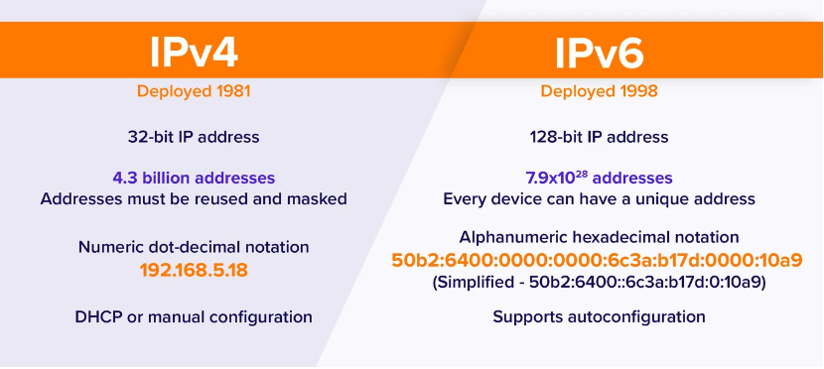

**DNS:**

* The Domain Name System (DNS) is the phonebook of the Internet
* Humans access information online through domain names, such as google.com or twetter.com
* Web browsers interact through IP addresses
* DNS translates domain names to IP addresses so browsers can load Internet resources.

**How to Internet works:**

* Sender --> ISP --> router --> ISP --> Recipient
* ISP: Internet Service Provider

**HTTP:**

* Hyper Text Transfer Protocol
* For fetching resources such as HTML documents
* It is the foundation of any data exchange on the Web and it is a client-server protocol which means requests are initiated by the recipient, usually the web browser.



**HTTP Layer:**

* HTTP is in the Application layer of the Internet protocol suite model and in the Session Layer of the OSI Model.

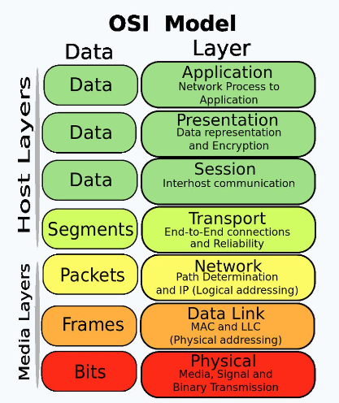 

**HTTP vs HTTPS:**

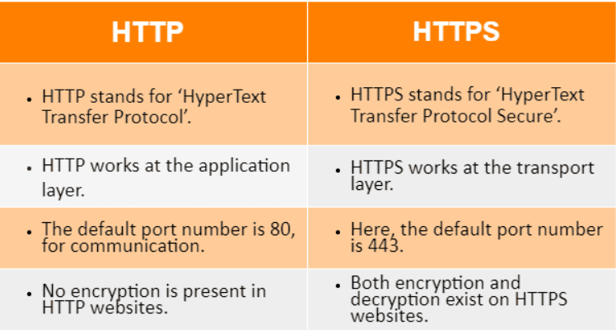

* Example:
  + HTTP: without password encryption
  + HTTPS: with password encryption